N.NITHISH
192512300
Ex.No:1: Simulation of FDMA in MATLAB

Aim: To simulate a Frequency Division Multiple Access (FDMA) system using MATLAB and analyze its communication performance in terms of channel bandwidth, data rate, and signal-to-noise ratio (SNR).
Objective 1:
To simulate an FDMA system by allocating individual frequency channels to multiple users and determine the channel bandwidth assigned to each user.
Output Parameter: Channel Bandwidth (kHz) Objective 2:
To calculate the data rate achieved by each user in the FDMA system based on the allocated channel bandwidth.
Output Parameter: Data Rate (kbps) Objective 3:

To evaluate the communication quality of the FDMA system by calculating the Signal-to-Noise Ratio (SNR) for different users.

Output Parameter: Signal-to-Noise Ratio (SNR) (dB) Procedure
- Open MATLAB and create a new script file.
- Define the total available bandwidth, number of FDMA users, carrier frequencies, signal power, and noise power.
- Allocate a unique frequency channel to each user and calculate the channel bandwidth.
- Compute the data rate for each user based on the allocated bandwidth and modulation scheme.
- Calculate the Signal-to-Noise Ratio (SNR) using the signal and noise power values.
- Plot the transmitted signals of all FDMA users using different carrier frequencies.
- Display the calculated channel bandwidth, data rate, and SNR in the MATLAB Command Window.
- Analyze the results to verify independent channel allocation and evaluate the overall performance of the FDMA system.

Objective 1 Program
clc; clear; close all; fs=1000; t=0:1/fs:1; TBW=600; Users=3;
CBW=TBW/Users; fc=[100 300 500];
m=sin(2*pi*10*t); s1=m.*cos(2*pi*fc(1)*t); s2=m.*cos(2*pi*fc(2)*t); s3=m.*cos(2*pi*fc(3)*t); subplot(2,1,1) plot(t,s1,'r',t,s2,'g',t,s3,'b'),grid on
title('FDMA Channel Allocation'),xlabel('Time (s)'),ylabel('Amplitude') subplot(2,1,2)
bar(1:Users,CBW*ones(1,Users)),grid on
xlabel('Users'),ylabel('Channel Bandwidth (kHz)'),title('Channel Bandwidth per User')

output
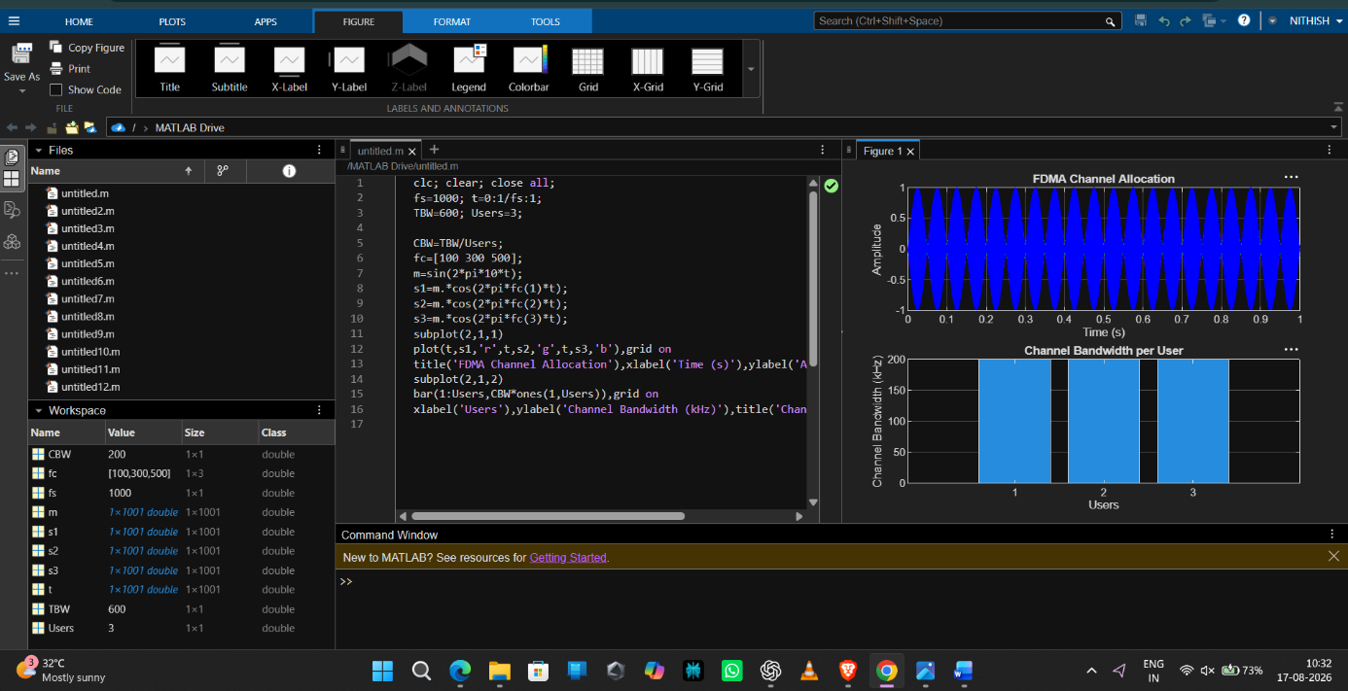

Objective 2 Program:
clc; clear; close all;
BW = 200; % Channel Bandwidth (kHz) Users = 3;
M = 2; % BPSK Modulation
DataRate = BW*log2(M); % Data Rate (kbps) Rate = DataRate*ones(1,Users);
disp(' User Data Rate (kbps)') disp([(1:Users)' Rate'])
figure bar(1:Users,Rate) xlabel('Users')
ylabel('Data Rate (kbps)')
title('FDMA Data Rate for Each User') grid on

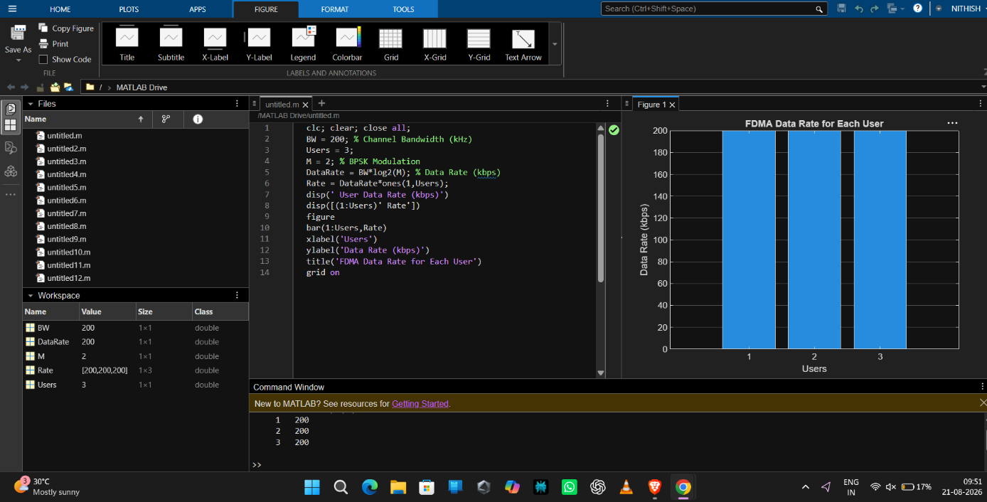
output:

Objective 3:
Program:
clc; clear; close all;
BW = 200; % Channel Bandwidth (kHz) Users = 3;
M = 2; % BPSK Modulation
DataRate = BW*log2(M); % Data Rate (kbps) Rate = DataRate*ones(1,Users);
disp(' User Data Rate (kbps)') disp([(1:Users)' Rate'])
figure bar(1:Users,Rate) xlabel('Users')
ylabel('Data Rate (kbps)')
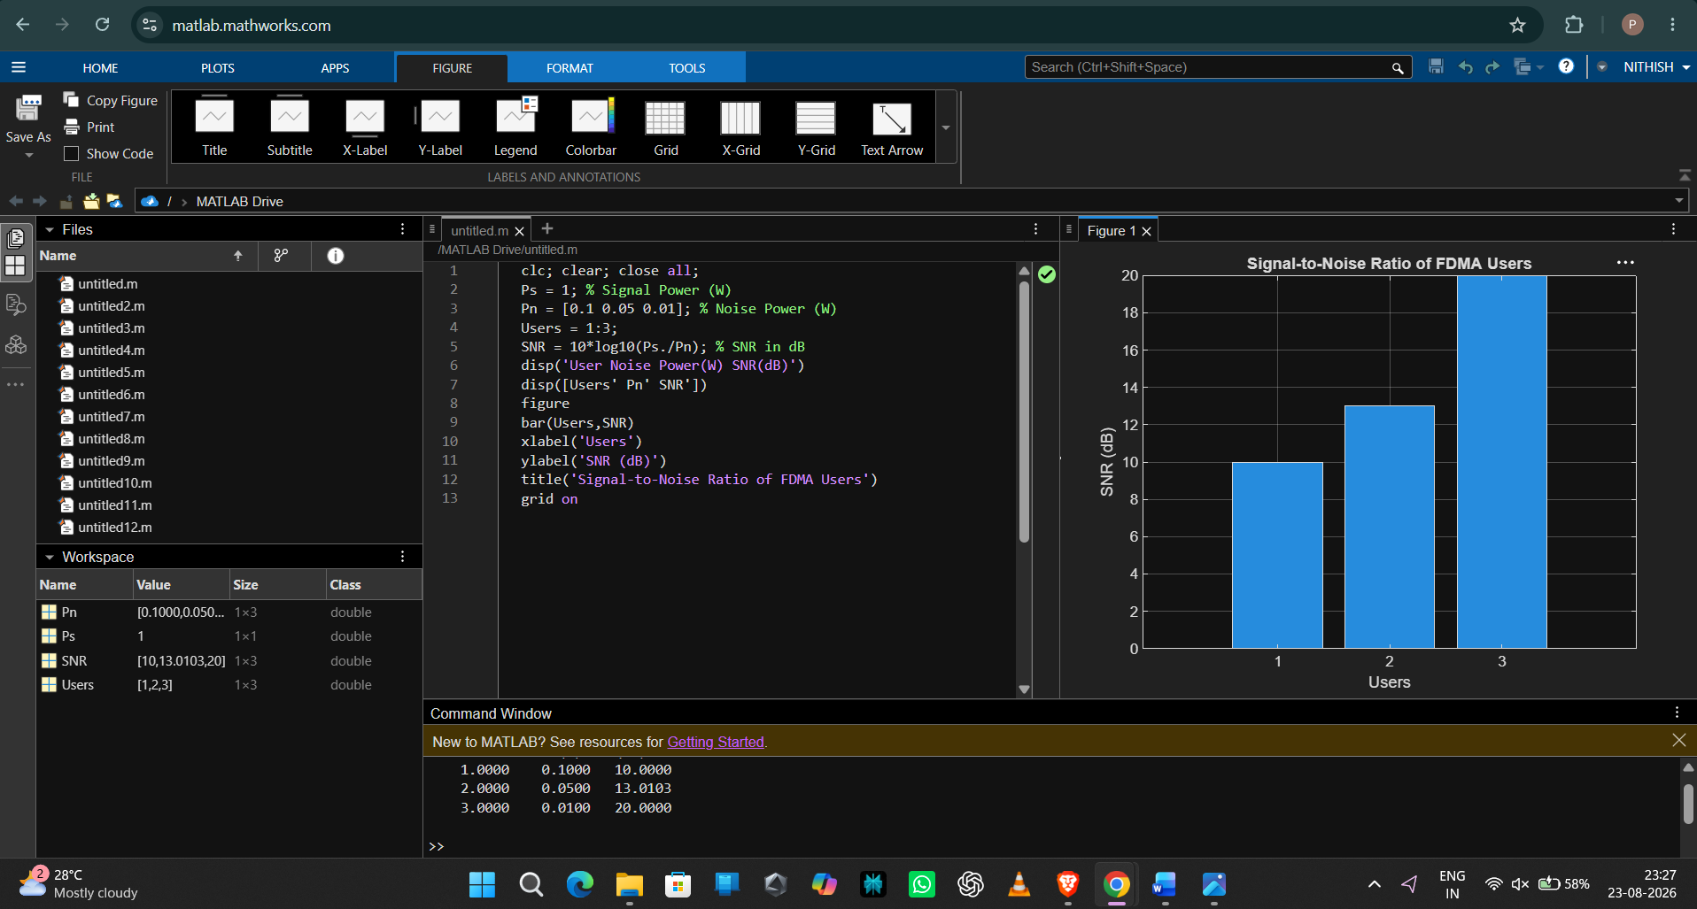title('FDMA Data Rate for Each User') grid on

Result:

- The FDMA system was successfully simulated by allocating separate frequency channels to three users, and the channel bandwidth assigned to each user was determined.
- The data rate achieved by each user was successfully calculated based on the allocated

channel bandwidth, demonstrating equal transmission capacity for all users.
- The Signal-to-Noise Ratio (SNR) for different users was successfully evaluated, showing that higher SNR values provide better communication quality and reliable data transmission.

